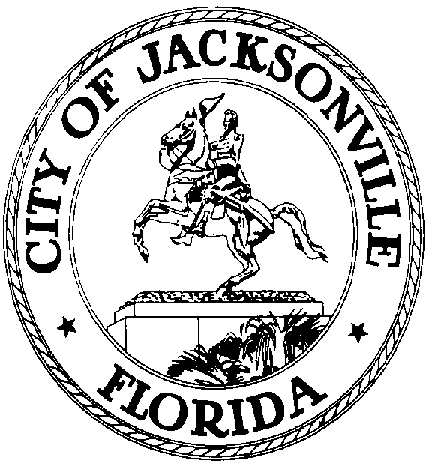

GARRETT L. DENNIS
Council Member District 9
E-Mail: GarrettD@coj.net

OFFICE OF THE CITY COUNCIL
117 West Duval Street City Hall, Suite 425
Jacksonville, Florida 32202
Office (904) 255-5209
Fax (904) 255-5230

REVISED MEDIA RELEASE

FOR IMMEDIATE RELEASE – June 3, 2020
Contact: Taryn Roberts (904) 255-5161, TGRoberts@coj.net

JACKSONVILLE CITY COUNCIL AND OTHER ELECTED OFFICIALS JOIN IN SOLIDARITY WALK

JACKSONVILLE, Fla. – After a discussion at the Special City Council Meeting and a plea for unity, City Council members and other elected local and state representatives will have a Solidarity Walk on Sunday, June 7, 2020 at 11:00 a.m. The walk will begin on the steps of City Hall, 117 West Duval Street, and end at the Jacksonville Fire Rescue – Station 1, 611 North Liberty St., Jacksonville, FL 32202.

“The citizens of Jacksonville are looking for leadership from their elected officials during this period of unrest due to racial inequality cross our nation,” Dennis said. “I have also invited the mayor and the sheriff to join this very important movement. We need to show the citizens who elected us that we see them, we hear them, and we care.”

